**Battling congestion and climate change for TFL (Plan)**

Congestion

[pic-20211013-item13a-part1-major-stations.pdf (tfl.gov.uk)](https://board.tfl.gov.uk/documents/s16692/pic-20211013-item13a-part1-major-stations.pdf)

Aspects of congestion in TFL: overcrowding.

A plan to tackle overcrowding in TFL for congestion is to invest in the improvement of infrastructure. The involvement of the infrastructure improvements in TFL includes to expand the capacity of the stations for the routes that needs this as requirement or for all of the routes such as ramps used in wheelchair access as well as footbridges to change platforms, and to create new walkable areas around all of the stations along the transits, so these methods will reduce the overcrowding of people in the TFL in public stations during the construction. This plan to improve the congestion on this case will need the requirements of materials and resources to build additional platforms for more people to access the entrance to the station or to access the exit from the station for the travel especially during the start of the journey towards the destination and to provide an extension for the facilities in all stations.

**This picture is about the upgrade in capacity including other features for a London underground station called Bank** **with its transit lines**

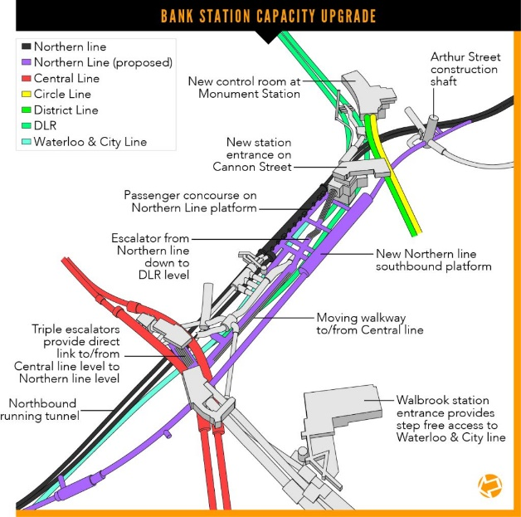

TFL REST API to use for congestion:

[Crowding](https://api-portal.tfl.gov.uk/api-details#api=crowding)

[Place](https://api-portal.tfl.gov.uk/api-details#api=Place)

[Road](https://api-portal.tfl.gov.uk/api-details#api=Road)

[Vehicle](https://api-portal.tfl.gov.uk/api-details#api=Vehicle)

[Lift Disruptions](https://api-portal.tfl.gov.uk/api-details#api=Disruptions-Lifts)

The importance of congestion for TfL

Congestion is a problem in London not just due to the rising number of cars, though. As the population grows, steps and the building of pavement are taken to accommodate more pedestrians, cyclists and bus journeys. Roads have been narrowed across London to allow more bike lanes and walking paths. A method that London is tackling the congestion is the use of ULEZ, which builds on the foundations of the Congestion Charge and has already delivered huge progress in tackling toxic air by targeting the most polluting vehicles.

Climate change

[Adapting to climate change - Transport for London (tfl.gov.uk)](https://tfl.gov.uk/corporate/about-tfl/adapting-to-climate-change)

Aspect of climate change: Weather forecasting

A plan to tackle weather forecasting is to implement a robust weather monitoring system in TFL for climate change to get real time data with its parameters. In this weather monitoring system, there would be a strategic placement of sensors across the TFL network to monitor and show the parameters for the temperature, humidity, the speed of wind, precipitation, detection of pollution and other parameters which will be useful for analysis.

**The features of a robust internet of things weather monitoring system that can be implemented in TFL**

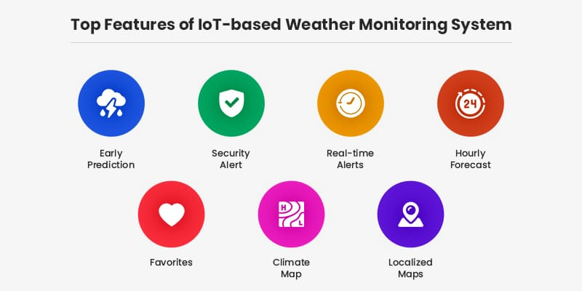

Most features from this TFL API called [AirQuality](https://api-portal.tfl.gov.uk/api-details#api=AirQuality) is already contained such as early prediction, hourly forecast and real time alerts. But, the use of maps for the climate map for people who want to monitor the weather and humidity level before starting or during the journey and the localised maps to analyse the statistics and the information of the local weather conditions should be included in the TFL website project for the visualisation of the data about the weather conditions and climate change.

TFL REST API to use for climate change:

[AirQuality](https://api-portal.tfl.gov.uk/api-details#api=AirQuality)

[Vehicle](https://api-portal.tfl.gov.uk/api-details#api=Vehicle)

The importance of climate change for TFL

Climate change refers to a large-scale, long-term shift in the planet's weather patterns and average temperatures. The climate change is increasing throughout time but the intensity and frequency of extreme weather events will also increase. The TFL will need to adapt its own transport system to stay resilient and create a more attractive, nature-rich, liveable city with stronger communities. The climate in London is changing because the country England is having hotter, drier summers and warmer, wetted winters. London is tackling climate change in two ways: to cut London’s greenhouse gas emissions to limit further climate change, and adapting to the changes in climate and extreme weather that are already happening. Adapting will help us to reduce the impact of climate change and weather upon Londoners.

Methods to leverage API here below:

[Application Programming Interface: The Ultimate How-To Guide (hubspot.com)](https://blog.hubspot.com/website/application-programming-interface-api)